1. ***Lesson Title***
2. ***Audiences - Trainees***
3. ***Instructional Goals***
4. ***Performance Objectives***
5. ***Objectives Assessment***
6. ***Instructional Strategy***
7. ***Instructional Materials***
8. ***Lesson Evaluation***

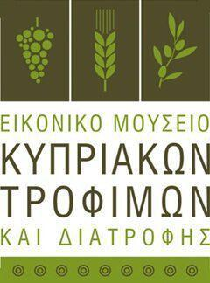******

***Lesson Title: The artisan and early industrial essence of the ‘Cypriot Traditional Festive Bread-Making’, through the lenses of a 4th generation baker: Maroulla Zouvani in making ‘Prosfora’ and ‘Panneisia’ at the beginning of 1960’s.***

***Audiences – Learners***

***The thematic unit and the demonstration on ‘Cypriot Traditional Festive Breads’ and the knowledge sharing workshop was organized by the Pastry and Baking Program of Study of MIEEK (Ministry of Education, Culture, Sports and Youth) in cooperation with the Cyprus Digital Food Museum. The aim of this thematic area was to expose all participants, to the artisan, early industrialized and traditional bread-making methods, techniques and ingredients used by a small, family-owned bakery for the production of ‘Prosforo’* and ‘Panneisia’**. Therefore, participants will gain the essential professional and technical knowledge and they will develop particular artisan skills in producing ‘Prosfora’ and ‘Panneisia’ according to the production practices used in early 60’s.***

***\* ‘Prosforo’: The Greek word for offering bread is prosforá which means an offering to God. The offering bread represents Jesus Who is the Bread of Life. It is baked by someone in the congregation and brought to the priest for each liturgy. Bread is used not only to represent Jesus Who is the Bread of Life, of which if any man eat he shall never hunger, but also to express the offering of our life to God. The priest accepts the gift and places it on the Holy Altar. This act represents God accepting our gift. It now passes into His possession and he transforms it through the Holy Spirit and gives it back to us as His Precious Body. A special seal is stamped on top of the loaf before it is baked. The middle part of the seal contains a square piece of bread with the words IC, XC, NIKA. This is a Greek abbreviation for JESUS CHRIST CONQUERS. Since this is the piece that will be changed into the Body of Christ, it is called the Lamb of whoGod. A large triangular piece is removed from the left of the Lamb of God and placed on the paten. This represents the Virgin Mary. Then nine smaller triangular pieces are removed from the seal to commemorate the angels, prophets, apostles and saints of the Church. These are placed on the paten to the right of the Lamb of God. Following this, the priest prays for the living members of the congregation, especially for those whose names have been submitted to him. As he prays for each name he cuts a small piece of bread, representing the person prayed for, and places it immediately below Jesus, the Lamb of God. Finally, he removes a piece of bread for each deceased person for whom we have requested prayers. Thus, around the Lamb of God on the paten is gathered the entire Church consisting of the angels, saints and loved ones in heaven together with members of the local congregation. ALL are alive in God's presence and all constitute the one living Body of Christ (sprint.net.au).***

***\*\* ‘Panneisia’: A big round sesame seeded, aromatic bread made of pre-fermented dough (produced with wild yeast). Usually, it comes in loaves of 1, 2, 3 or even 4kg and it is produced with an effort to thanks given to the patron saint of the celebrator or the person who made the feast. Also, it may be offered for the desires for and in memory of the souls of those who passed away. The dough is rolled in the sesame seeds and then it is flatted, using a roller bin. Different shapes are crafted on the top using a pair of scissors, forks and various stencils. The bread decorations on top are part of a symbolism related to life, eternity and Jesus crucifixion. In certain places the decoration is completed by placing on top of the flatted bread various shapes and designs made of the same dough.***

***Instructional Goals:***

***Upon successful completion of the knowledge sharing workshop/ demonstration students will:***

* ***Be aware of the historical, religious, socio-cultural dimension of the Cypriot festive breads in everyday life.***
* ***Comprehend the artisan, traditional and early industrial method, techniques and ingredients used for the production of Cypriot festive breads, such as ‘Prosfora’ and ‘Panneisia’ in small family-owned bakeries.***
* ***Reflect on the uniqueness, the importance and significance of the ‘Cypriot Festive Breads’ merceo***
* ***logy, in order to sustain workplace best practices, and infuse with modernized elements the production of Cypriot Festive Breads.***

***Lesson Objectives***

***At the end of this presentation participants will be able to:***

1. ***Provide a historical overview of the origin, progress, symbolism, the theological bonds and the socio-cultural dimension of ‘Prosfora’ and ‘Panneisia’.***
2. ***Explain the bread-making process and ingredients used, according to Maroulla’s case-study.***
3. ***Present the basic-traditional ingredients, tools and utensils used by Maroulla in the production of ‘Prosfora’ and ‘Panneisia’.***
4. ***Specify the main stages in the production of ‘Prosfora’ and ‘Panneisia’.***
5. ***Make a comparison and outline the differences between the traditional and the modern methods and ingredients used in the production .***
6. ***Acknowledge production quality points and standards along with the quality characteristics of the final product.***
7. ***Produce, decorate and bake ‘Prosfora’ and ‘Panneisia’ according to the traditional method.***

***Objectives Assessment***

* ***Provide a historical overview of the origin, progress, symbolism, the theological bonds and the socio-cultural dimension of ‘Prosfora’ and ‘Pita tis Ekklissias’.***

***Definitions***

***‘Korta’***

***The word was probably derived from the process of cutting the bread into thick slices in the churchyard immediately after the service.***

***Pannesida (Pannesia)***

***Wide and common term used mainly in villages.***

***‘Pita tis Ekklissias’ (Bread of the Church)***

***A newer term used primarily in cities. It most likely to have come from the social progress and development, and improvement in literature.***

***Religious Dimension / Refer to:***

* ***Names of Saints – (Name day)***
  + ***Thanks given to the patron saint of the celebrator or the person who made the feast.***
* ***In-Memory*** 
  + ***Desires for and in memory of the souls of those who passed away.***
* ***It was made at home by 'clean' women (spiritually and physically pure).***
* ***Position and significance of the ‘Holy Bread’ during the Service (Religion/Church)***
* ***Pannesia was sliced and offered to people on Saturday late afternoon and after the evening pray or Sunday morning after the Divine Liturgy.***

***Sociocultural Dimension / Refer to:***

* ***Role of Women / Famous for their artisan skills***
  + ***Production process / lifestyle***
    - ***Celebrations / Psichosavvato / Saturdays / Every Saturday afternoon***
  + ***Art and Love***
    - ***Symbolism in decoration***
  + ***Securing a livelihood***
* ***Economic status and therefore the social position of the consumer.***
  + ***Large, ‘ploumisto’ (decorated) and ‘kapartisto’ ' (2 - 4 kg).***
  + ***Pannesia’s higher costs compared to ‘Prosforo’.***
* ***Explain the bread-making process and ingredients used, according to Maroulla’s description in her case-study.***
* ***3rd generation baker***
* ***Stone oven / wood-fired / everything prepared in hand***
* ***‘Pentarti’ (three kinds of festive breads)***
* ***Production***
  + ***Sour dough starter (pre-fermented dough made of wild yeast)***
    - ***Typical sour taste.***
    - ***Drosos / Holy water (Theophania / 7th of January) / Blessed Water (practice from a distant past)***
    - ***Alternative options: Onion leafs***
  + ***Crossing (three times in the name of Holy Trinity), Blessing and producing the prefermented-sour dough -dressing with the preparation of yeast (3 times)***
    - ***Daily dough refreshing***
  + ***Temperature / natural environment***
  + ***Last item in production / late in the afternoon***
    - ***Slow fermentation due to sour dough / baking next day with the sunrise***
* ***Recall the differences between the traditional and the modern methods and ingredients used in the production.***
  + - ***Yeast in recipes***
    - ***Types of flour***
    - ***Types of bread-mixers***
    - ***Lost theological and socio-cultural magic due to mass production***
    - ***Mixing method***
    - ***Ovens***
    - ***Highly commercialized commodity***
* ***Present the basic-traditional ingredients, tools and utensils used by Maroulla in the production of ‘Prosfora’ and ‘Panneisia’.***

***‘Prosfora’***

* + - ***Durum wheat flour***
    - ***Salt***
    - ***Water***
    - ***Sour dough***

***‘’Panneisia’***

* ***Durum wheat flour***
* ***Sugar***
* ***Salt***
* ***Sour dough***
* ***Mastiha & Mexlepi***
* ***Cinnamon & Anise***
* ***Sesame seeds***
* ***Black sesame seeds***

***Equipment, tools and utensils***

* ***Stone oven, wood-fired***
  + ***Bread returns could be used to heat the oven***
* ***Bread mixer*** 
  + ***outdoor installation of mechanical components***
  + ***first models***
  + ***engine / outside the production area due to smoke and CO2***
* ***Baking trays***
* ***Specify the main stages in the production of ‘Prosfora’ and ‘Panneisia’.***
  + - ***Sour dough starter***
    - ***Measuring ingredients***
    - ***Mixing the ingredients***
    - ***Dough rest to ferment***
    - ***Portioning and pre-shaping***
    - ***Rest***
    - ***Final shaping***
      * ***Panneisida:***
        + ***Roll in roasted sesame seeds***
        + ***Decorate using a pair of scissors, blade, forks for the decoration***
      * ***Prosforo:***
        + ***Placing the wooden mold on top in order to stamp it with the particular shape ‘offering’***
* ***Acknowledge production quality points and standards along with the quality characteristics of the final product.***
  + - ***appealing brownish and crunchy crust,***
    - ***air pockets and glossy interior***
    - ***pleasant roasty aroma,***
    - ***fine slicing characteristics,***
    - ***soft and elastic crumb texture,***
    - ***moist mouthfeel.***
* ***Produce, decorate and bake ‘Prosfora’ and ‘Pita tis Ekklissias’ according to the tradition.***

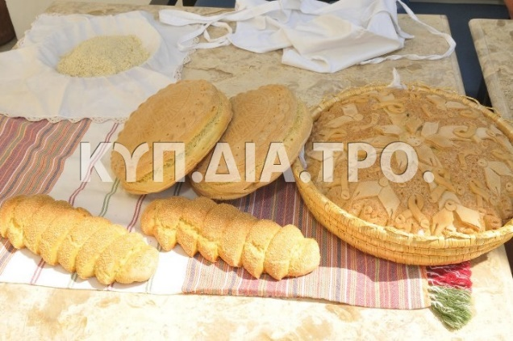

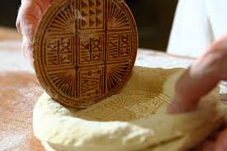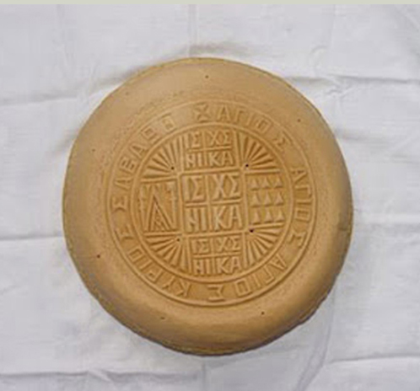

***Instructional Strategy***

***As diversified instructional strategy will be adopted in bridging the traditional and modern Cypriot festive breads.***

***Step 1:***

***Prior presentation/demonstration commencement:***

* ***Flipped Classroom: It will reverse the traditional learning environment by delivering instructional content, online, through MIEEK’s Moodle. This is important in order to provide to students all the thematic units related, pre or core-requisite information. The provided teaching and learning materials will familiarize students in advance with the thematic area. As a result, they will be well-prepared (in terms of theory, technology and related professional background) for the in-class learning activities may enhance the learning process in the class. The content uploaded on Moodle, will include a PPT on the following items:***
  + ***Cypriot Festive Breads***
    - ***Definitions***
  + ***Religious Influences***
  + ***Sociocultural Dimension***
  + ***Bread-making process and ingredients, according to Maroulla’s case-study***
  + ***Differences between the traditional and the modern methods and ingredients used in the production***
  + ***Bread-making and ingredient technology***
  + ***Specify the main stages in the production of ‘Prosfora’ and ‘Panneisia’.***
  + ***Production quality points and standards along with the quality characteristics of the final product***

***The flipped classroom will serve as an induction for all participants. There will be available video clips to present festive breads as well as the bread-making process.***

***Step 2:***

***During the presentation/demonstration***

* ***Lecturing will assist in the introduction of the new thematic area under discussion, setting the pathway and the direction of the presentation. The PPT will introduce the main information***

***(class commencement 15’)***

* ***Guest lecturer: In order to enhance, energize and color all efforts employed to achieve the learning outcomes, Mrs Maroulla Zouvani we disclose her experience and advises concerning all traditions in Cypriot artisan and festive breads.***

***(Presentation 10’)***

* ***Cooperative learning / Group discussion: Students will work in groups of three in order to keep a small number of students to allow everyone to learn from each other’s different experience. Thus, to offer an opportunity to present, new and different practices from the participants' background and family traditions.***

***(Group discussion 20’)***

* ***Independent study: It will be requested by the students to undertake an independent study, as a homework, in order to enhance their learning experience. Thus to assist students to build their new knowledge based on the material presented and discussed in the class in relation to their personal experience. The topic will focus on gathering and analyzing information related to traditional Cypriot festive products being prepare in participants’ regions/villages. This will help students to reflect on their experience. The independent study will be expressed via the preparation of a portfolio which it will include qualitative relevant information and audiovisual material gathered during their research.***

***(Instructions 5’)***

* ***Demonstration: The demonstration of the Cypriot festive breads (Panneisia and Prosforo) will be occurred by the guest visitor, having the support of the chef instructor. ‘Paneisida’ and ‘Prosfor’ will be produced a day ahead, using the slow fermentation process (be stored in the fridge) in order to have available for baking during the demonstration day. The guest visitor and chef instructor will focus on the production process.***

***(demonstration 170’)***

***Instructional Materials***

***In-class Presentation***

* ***Moodle / 365***
* ***PPT***
* ***Projector***
* ***Special utensils, equipment and ingredients***

***Demonstration***

* ***Baking lab***

***Equipment, utensils and ingredients***

***Recipes***

***Lesson Evaluation***

***Expected learning outcomes will be assessed as follow:***

***Formative Assessment:***

1. ***Continuous questioning and answering during the presentation and the demonstration in order to detect any gaps in the learning process.***
2. ***Qualitative assessment of the independent study portfolio/report.***
3. ***Test on the key principles, production methods and quality points of the thematic unit (Exit card).***
4. ***Students practice / recipe production / practical assessment the week after.***
5. ***Benchmarking during students’ practice.***